STUDENT AI-TOOL USAGE ANALYTICS

(2025)

45 DAYS INDUSTRIAL TRAINING PROJECT REPORT

Submitted by
NISHCHAL SOOD

in partial fulfilment for the award of the degree of

BACHELOR OF TECHNOLOGY

IN

COMPUTER SCIENCE AND ENGINEERING
AT


SUBMITTED TO: SUBMITTED BY:
Mrs Mehak Kohli Nishchal Sood
12300865

DEPARTMENT OF COMPUTER SCIENCE AND ENGINEERING
DAV UNIVERSITY
JALANDHAR-PUNJAB 144012

CANDIDATE'S DECLARATION

I hereby certify that the work which is being presented in the project report entitled “AI tools used by student prediction” by “Nishchal Sood” in partial fulfilment of requirements for the award of degree of B.Tech. (CSE) submitted in the Department of CSE at DAV University, Jalandhar is an authentic record of my own work carried out under the guidance of Mrs Mehak Kohli.

Signature of the Student Nishchal sood 12300865 B. Tech CSE- C04B

This is to certify that the above statement made by the candidate is correct to the best of my knowledge.

Signature of Examiner(s)

The B. Tech Viva –Voce Examination of Nishchal Sood has been held on and accepted.

Signature of Examiner

Signature of H.O.D

ACKNOWLEDGEMENT

I would like to express my sincere gratitude to my project guide Mrs Mehak Kohli for their valuable guidance, constructive feedback, and continuous support throughout the duration of this project. I am also thankful to the Department of Computer Science and Engineering for providing the necessary resources and an encouraging academic environment.

My appreciation extends to all faculty members and classmates whose suggestions and cooperation helped strengthen the quality of this work. Lastly, I am deeply grateful to my family for their constant encouragement and support, which motivated me to complete this project successfully.
Nishchal sood
12300865
B. Tech CSE- C04B

Training Certificate
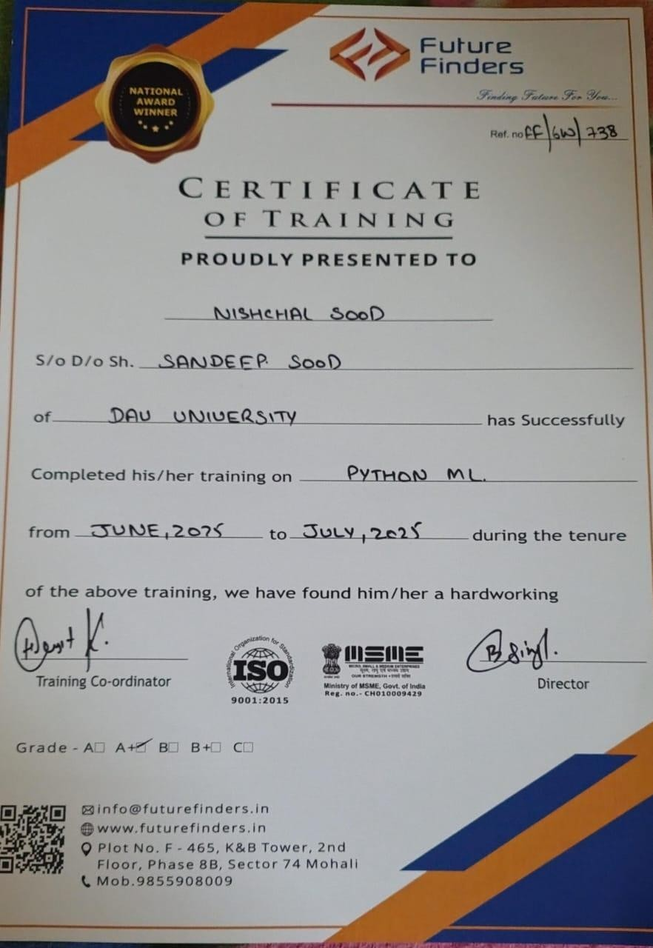

ABSTRACT

The integration of Artificial Intelligence (AI) in education has revolutionized how students learn, research, and interact with technology. AI tools such as ChatGPT, Gemini, Copilot, and others have rapidly become essential components of students’ academic activities, helping them with coding, writing, research, data analysis, and project planning.
This project presents a detailed analysis and prediction system designed to understand student AI-tool usage behavior based on survey data. Using Python-based data analytics and a machine learning model, a complete Streamlit dashboard was developed to visualize data trends, explore user insights, and predict daily usage hours for new student profiles.
The dashboard includes multiple interactive charts, such as device usage comparison, state-wise usage heatmaps, trustlevel distribution, and awareness-level analysis. A Random Forest Regression Model is trained to predict estimated daily AI-tool usage hours based on user-selected attributes like Year of Study, State, Trust Level, Device Used, and Preferred AI Tool.
This project demonstrates the practical application of machine learning, data visualization, and interactive dashboard development. It serves as a useful tool for educators, institutions, and researchers to study student dependency on AI technologies and derive meaningful patterns from real-world data.

TABLE OF CONTENTS

Chapter NO. TOPIC Pg.
No.
Title Page 1
Declaration 2
Acknowledgement 3
Certificate of Industrial Training 4
Abstract 5
Table of Contents 6
List of Figures 7
CHAPTER 1 – INTRODUCTION 8-9
CHAPTER 2 – PROJECT OVERVIEW 10-11
CHAPTER 3 – TOOLS & TECHNOLOGIES 12-13
CHAPTER 4 – METHODOLOGY 14-15
CHAPTER 5 – CODING & IMPLEMENTATION 16-19
CHAPTER 6 – CONCLUSION 20
CHAPTER 7 – FUTURE SCOPES 21

LIST OF FIGURES

Fig.no. Title Page No.
1.1 Industrial training certificate 4
1.2 Project Structures &imports 16
1.3 Diagram of Streamlit Page Setup 16
1.4 Schematic Diagram of a Dataset Loading & caching 17
1.5 Diagram of splitting data 17
1.6 Diagram of Prediction of logic 18
1.7 Training of ML model 18
1.8 Raw Data Viewer 19

CHAPTER 1 :

INTRODUCTION

1.1 What is Artificial Intelligence?
Artificial Intelligence (AI) refers to the simulation of human intelligence in machines that are capable of performing tasks that normally require human-like thinking. These tasks include learning, reasoning, problem-solving, perception, and decision-making.
AI is now widely used in:
- Education
- Healthcare
- Finance
- Cybersecurity
- Data Analysis
- Customer Service
- Robotics

1.2 Machine Learning
Machine Learning (ML) is a branch of AI that allows systems to learn automatically from data and improve their performance without being explicitly programmed. ML helps computers understand patterns and make predictions.
Major types of ML:
- Supervised Learning
- Unsupervised Learning

• Reinforcement Learning

1.3 Python in AI
Python is the most preferred language for AI and ML due to:
- Simple syntax
- Powerful libraries
- Strong community support
- Fast development

CHAPTER 2 :

PROJECT OVERVIEW

2.1 Introduction

This project involves analyzing how students use AI tools in their daily academic life. It aims to visualize various aspects of AI-tool usage through an interactive dashboard and predict daily usage hours using machine learning.
The Streamlit dashboard allows users to:
- Filter data
- View analytical charts • Explore usage trends
- Predict daily AI usage

2.2 Objectives

The main objectives include:
- Understanding student behavior and preferences
- Analyzing the relationship between usage patterns and trust/awareness levels
- Visualizing data through charts
- Creating a prediction model
- Providing an easy-to-use dashboard

2.3 Dataset Description

The dataset contains:
- State
- Device Used
- Preferred AI Tool
- AI Tools Used
- Daily Usage Hours
- Trust in AI Tools
- Awareness Level
- Year of Study
This dataset is suitable for regression analysis.

2.4 Data Preprocessing

Steps include:
- Removing inconsistencies
- Handling missing values
- Converting categorical data using one-hot encoding
- Applying filtering for better visualization
- Encoding user inputs for predictions

2.5 Machine Learning Model

A Random Forest Regressor is used because it:
- Handles categorical encodings well
- Provides high accuracy
- Avoids overfitting
- Works efficiently with large data

2.6 Prediction for New Students

Users can input:
- Year of Study
- AI Tools Used
- Preferred AI Tool
- Trust Level
- Device Used
- State
The model predicts estimated daily usage hours.

2.7 Visual Insights & EDA

Dashboards include:
- Usage by AI Tool vs Device
- State-wise usage heatmap
- Trust vs Year of Study

2.8 Conclusion
The project provides valuable insights into student AI usage behavior, serving educators,researchers, and study.

CHAPTER 3 :

TOOLS AND TECHNOLOGIES USED

The development of the Student AI-Tool Usage Analysis & Prediction System required a combination of programming languages, libraries, tools, and platforms that support data preprocessing, machine learning, visualization, and interactive dashboard development. This chapter provides a comprehensive explanation of all the technologies used throughout the project.

3.1 Programming Language – Python

Python was chosen as the core programming language because of its simplicity, versatility, and vast ecosystem of libraries tailored for data science and machine learning. Key features of Python that make it ideal for AI projects include: • Readable syntax that resembles natural language
- Cross-platform compatibility
- Large community support
- Integration with other languages and technologies
- Availability of scientific and ML libraries
Python enabled seamless development of the backend data processing, machine learning training, and integration with the Streamlit framework for UI development.

3.2 Python Libraries (Data Handling & Machine Learning)

Pandas
Pandas is the core library used for data manipulation, preprocessing, and transformation. Its DataFrame structure makes it easy to clean, explore, and group survey data.
Pandas was used for tasks such as:
- Reading CSV files
- Handling missing values
- Filtering and grouping responses
- Applying transformations
- Preparing data for ML algorithms

NumPy
NumPy supports efficient handling of large arrays and numerical computations. It was used for:
- Mathematical operations
- Data conversion
- Statistical calculations
- Matrix operations required for ML
Scikit-Learn
The machine learning workflow heavily relied on Scikit-Learn. It provided:
- Random Forest Regressor (ML model)
- Train-test splitting
- Data preprocessing tools
- Performance evaluation (MAE, RMSE)
Scikit-learn's reliable and structured API made model development efficient and easy.

3.3 Data Visualization Tools

Altair
Altair was the major visualization library used due to its powerful declarative syntax and smooth integration with Streamlit. Altair was used to generate:
- Bar charts
- Heatmaps
- Stacked bar graphs
- Device/tool usage charts
- Trust and awareness visualizations
Altair's interactivity brings the dashboard to life, allowing users to explore visual data effortlessly.
Matplotlib & Seaborn (Optional)
While Altair handled most charts, Matplotlib and Seaborn may be used for:
- Distribution plots
- Correlation heatmaps
- Statistical graphs
They support deeper insights during EDA (Exploratory Data Analysis).

3.4 Machine Learning Tools

Jupyter Notebook / Google Colab
Used during model experimentation and EDA before integrating into Streamlit. These tools support:
- Step-by-step code execution
- Graphical outputs
- Inline visualizations
- Fast prototyping
Streamlit
Streamlit was used to build the full application interface. It enables:
- Real-time ML prediction
- Sidebar filters
- Tabs for structured analysis
- Interactive charts
- Data display
- Model evaluation visuals
Streamlit’s simplicity makes it ideal for turning ML code into a usable web application.

3.5 Data Preprocessing Techniques

One-Hot Encoding
Categorical values such as State, Device Used, Preferred AI Tool, and Awareness Level were converted into numerical columns using one-hot encoding.
Label Cleaning
All text entries were normalized and converted to string format to avoid type mismatches.
Train-Test Split
80% of data was used for training, and 20% for testing.
Feature Engineering
Features were selected and transformed to ensure optimal model performance.

3.6 Dataset Source

The dataset used in this project was collected via a student survey and stored in a CSV file named Students.csv. It reflects real-world student experiences, making the model more accurate for practical usage.

3.7 Optional Technologies

Technologies that can improve future versions include:
- Flask / FastAPI: To deploy the ML model as a web API
- Docker: Containerization for scalable deployment
- GitHub: Version control and collaboration
- Cloud Platforms (AWS, Azure, GCP): Hosting the dashboard online

CHAPTER 4 :

METHODOLOGY

4.1 Importing Libraries

All necessary libraries for ML, data visualization, and dashboard development are imported.

4.2 Loading Dataset

The dataset is loaded using a cached function in Streamlit for performance improvement.

4.3 Data Preprocessing

- Converting all text fields to string
- Creating dummy variables
- Handling missing values
- Splitting data

4.4 Sidebar User Input Section

Users select:
- Year
- State
- Device
- Trust Level
- Preferred AI Tool
- AI Tools Used

  - Train-Test Split

Data is split into training and testing sets.

  - Model Training

Random Forest Regression model is trained with 300 estimators.

4.7 Model Evaluation Metrics

Evaluated using:
- MAE
- RMSE

4.8 Prediction

User input is processed and sent into the model to output predicted daily usage.

4.9 Data Visualization

Charts created using Altair include:
- Bar charts
- Heatmaps
- Stacked graphs

4.10 Raw Data Viewer

Dataset preview provided using Streamlit's dataframe viewer.

CHAPTER 5 :

CODING AND IMPLEMENTATION

This chapter explains the complete structure of the implemented system, including how code is organized, how the dashboard is built, and how the machine learning model is integrated into the application

.

5.1 Project Structure & Imports
The project is structured into clear sections:
- Importing all required libraries
- Setting up the Streamlit interface
- Loading and preprocessing the dataset
- Creating visualizations
- Training the ML model
- Handling user input
- Performing predictions
- These imports cover data processing, visualization, ML modeling, and dashboard integration.
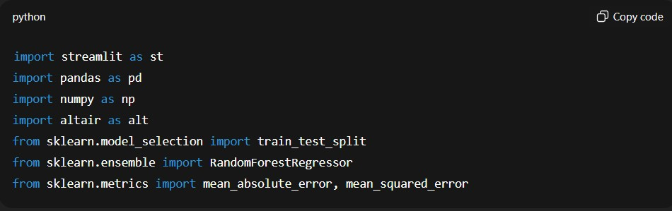
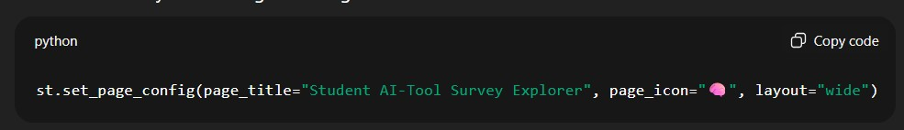

5.2 Streamlit Page Setup
The dashboard layout is configured using:

This ensures a professional UI with a responsive wide layout.

5.3 Dataset Loading & Caching

This function ensures the dataset is not reloaded multiple times, improvingspeed.

5.4 Data Preprocessing
Preprocessing includes:
- Type conversions
- Cleaning invalid entries
- One-hot encoding categorical variables
- Grouping and aggregating data for charts

5.5 Sidebar Filters & Prediction Inputs
Streamlit provides user interface widgets such as:
- selectbox()
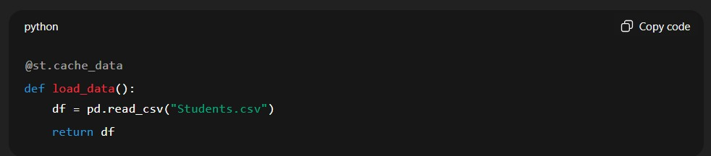
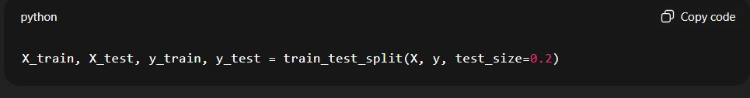
- multiselect()
- slider()
- form()
These allow users to filter the dataset and enter personal details for prediction.

5.6 Splitting Data
The dataset is split for training and testing:

5.7 Training the ML Model
The Random Forest Regressor is trained:

The model learns patterns from the survey dataset to predict daily usage hours.

5.8 Model Evaluation Metrics
Evaluation metrics such as:
Mean Absolute Error (MAE)
• Root Mean Square Error (RMSE) are calculated:
These metrics help understand the accuracy of predictions.

5.9 Prediction Logic
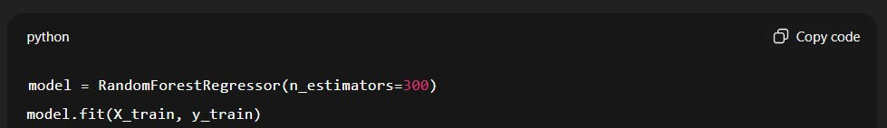
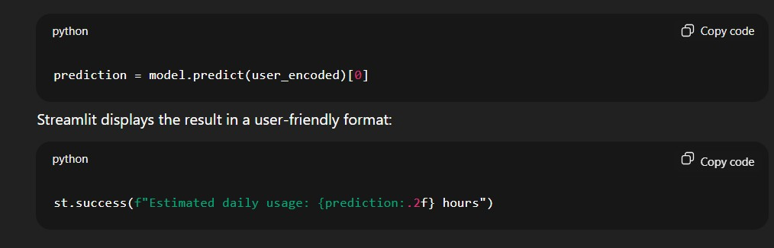
User input is encoded and fed into the trained model:

5.10 Exploratory Data Analysis (EDA)
Visualizations include:
- Bar charts
- Heatmaps
- Stacked charts
- Line graphs
Altair is used to create clear, interactive visual insights.

5.11 Raw Data Viewer
Stream lit’ data frame viewer allows users to inspect the dataset:

This ensures transparency and helps users understand the underlying data.

5.12 Dashboard Interface Explanation
The interface includes:
- A sidebar for filtering and prediction
- Tabs for insights
- Interactive visualizations
- A dedicated prediction section
- Raw data preview
The design focuses on simplicity, ease of use, and clarity.

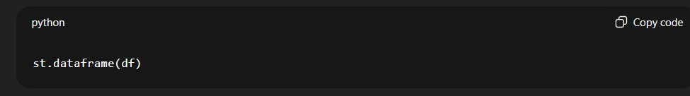

CHAPTER 6 :

CONCLUSION

6.1 Conclusion

The Student AI-Tool Usage Analysis & Prediction System successfully integrates machine learning, interactive dashboards, and real-world survey data to provide deep insights into students’ AI usage patterns.
Key achievements include:
- Clear understanding of how students use AI tools
- Interactive visualizations highlighting trends
- An ML model capable of predicting daily usage hours
- A user-friendly dashboard built with Streamlit
This project demonstrates the power of combining data science with web technologies to solve real-world problems.

The visual analytics enable educational institutions and researchers to understand how students adopt AI in their learning process. Additionally, the Random Forest prediction model accurately estimates the daily usage hours of a student based on categorical features such as year of study, device type, AI tools used, and trust in AI.
With prediction accuracy measured through MAE and RMSE values, the model proves efficient and suitable for practical use.
Overall, the project demonstrates the power of data-driven decision making, combining machine learning and interactive visualization to study real student behaviour. It lays a strong foundation for further research in AI-driven educational technologies.

CHAPTER 7:

FUTURE SCOPES

7.1 The system can be significantly enhanced by adding:
1. Advanced Machine Learning Models These can improve prediction accuracy.

2. Feature Engineering Improvements

Incorporate additional factors such as:
- Type of course
- Internet speed
- Device performance
- Academic workload
- Number of AI tools used daily

3.Deployment at Scale

Deploying the dashboard on:
- AWS
- Azure
- Streamlit Cloud
- Google Cloud
This would allow access to a larger audience.

4.Real-Time Data Collection

Integrating live forms or APIs to continuously update the dataset.
5. Explainable AI
Using SHAP or LIME to understand why the model predicts certain usage values.

7.2 How This Project Helps

- Educational Institutions: Understand student dependency on AI.
- Researchers: Analyze trends in AI adoption.
- Students: Gain insights into their own usage behavior.
- Developers: Improve AI tool usability based on analytics.
- EdTech Companies: Target features students use most.
This project contributes to the growing field of AI usage analysis and sets a foundation for future academic research and technological development.

REFERENCES / BIBLIOGRAPHY

- Python.org Documentation
- Scikit-Learn User Guide
- Streamlit Documentation
- Research papers on AI in Education
- Online tutorials and training resources

Books & Academic Resources:

- Géron, Aurélien. Hands-On Machine Learning with Scikit-Learn, Keras, and TensorFlow. O’Reilly Media, 2022.
- Goodfellow, Ian, Yoshua Bengio, and Aaron Courville. Deep Learning. MIT Press, 2016.
- Bishop, Christopher M. Pattern Recognition and Machine Learning. Springer, 2007.

